**Planta do Sistema**

$$G\left(s\right)=\frac{10}{\left(s+2\right).\left(s+1\right).(s+5)}$$

Condições do problema: $$e_{ss}≤2\% ao degrau$$

$$ζ=0,6$$

Controlador Proporcional

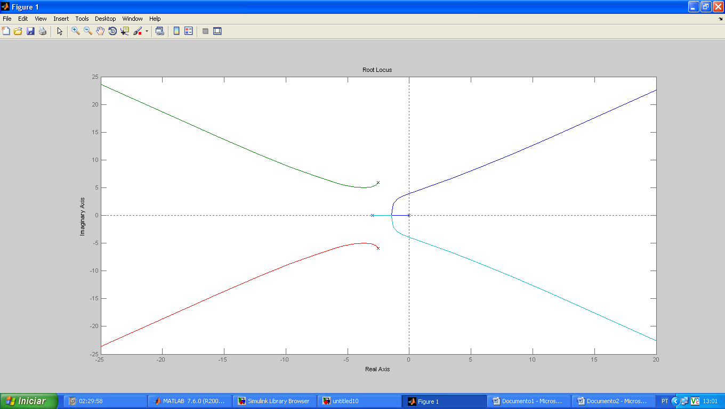

k1 =

11

>> k1=11.6

k1 =

11.6000

>> D4=(conv([1 5],[1 3 2])+[0 0 0 10*k1])

D4 =

1 8 17 126

>> N4=[10 0]

N4 =

10 0

>> rlocus(N4,D4)

>> sgrid(0.6,0)

>> rlocfind(N4,D4)

Select a point in the graphics window

selected_point =

-2.2869 + 5.5278i

ans =

3.4678

>> rlocfind(N4,D4)

Select a point in the graphics window

selected_point =

-2.2486 + 5.3743i

ans =

3.3182

>> [k4 p1]=rlocfind(N4,D4)

Select a point in the graphics window

selected_point =

-2.1526 + 5.3743i

k4 =

3.2564

p1 =

-2.1266 + 5.3950i

-2.1266 - 5.3950i

-3.7469

>> N5=10

N5 =

10

>> k4=4,07

k4 =

4

ans =

7

>> k3=4,07

k3 =

4

ans =

7

>> D4=(conv([1 0],[1 5],[1 3 2])+[0 0 0 10*k3 10*k1])

??? Error using ==> conv

Too many input arguments.

>> D4=(conv([1 0],conv[1 5],[1 3 2])+[0 0 0 10*k3 10*k1])

??? D4=(conv([1 0],conv[1 5],[1 3 2])+[0 0 0 10*k3 10*k1])

|

Error: Unbalanced or unexpected parenthesis or bracket.

>> D4=conv([1 0],conv[1 5],[1 3 2])+[0 0 10*k3 10*k1])

??? D4=conv([1 0],conv[1 5],[1 3 2])+[0 0 10*k3 10*k1])

|

Error: Unbalanced or unexpected parenthesis or bracket.

>> D4=conv([1 0],conv([1 5],[1 3 2])+[0 0 10*k3 10*k1])

D4 =

1 8 57 126 0

>> rlocus(N4,D4)

>> sgrid(0.6,0)

>> D5=(conv([1 0],conv[1 5],[1 3 2])+[0 0 0 10*k3 10*k1])

??? D5=(conv([1 0],conv[1 5],[1 3 2])+[0 0 0 10*k3 10*k1])

|

Error: Unbalanced or unexpected parenthesis or bracket.

>> D5=(conv([1 0],conv([1 5],[1 3 2])+[0 0 0 10*k3 10*k1])

??? D5=(conv([1 0],conv([1 5],[1 3 2])+[0 0 0 10*k3 10*k1])

|

Error: Expression or statement is incorrect--possibly unbalanced (, {, or [.

>> D5=conv([1 0],conv([1 5],[1 3 2])+[0 0 0 10*k3 10*k1])

??? Error using ==> plus

Matrix dimensions must agree.

>> D5=conv([1 0],conv([1 5],[1 3 2])+[0 0 10*k3 10*k1])

D5 =

1 8 57 126 0

>> rlocus(N5,D5)

>> [k5 p1]=rlocfind(N5,D5)

Select a point in the graphics window

sgrid(0.6,0)

selected_point =

-7.8767 +11.6123i

k5 =

2.5315e+003

p1 =

-10.4375 + 9.4243i

-10.4375 - 9.4243i

6.4375 + 9.3041i

6.4375 - 9.3041i

>> [k5 p1]=rlocfind(N5,D5)

Select a point in the graphics window

selected_point =

-1.3556 + 1.8234i

k5 =

18.9639

p1 =

-2.6941 + 5.5379i

-2.6941 - 5.5379i

-1.3059 + 1.8151i

-1.3059 - 1.8151i

>> [k2 p1]=rlocfind(N5,D5)

Select a point in the graphics window

selected_point =

-1.3124 + 1.8234i

k2 =

19.0402

p1 =

-2.6953 + 5.5360i

-2.6953 - 5.5360i

-1.3047 + 1.8221i

-1.3047 - 1.8221i

Warning: Output port 1 of 'untitled10/Step1' is not connected.

Warning: Input port 1 of 'untitled10/Sum' is not connected.

Warning: Using a default value of 0.2 for maximum step size. The simulation step size will be equal to or less than this value. You can disable this diagnostic by

setting 'Automatic solver parameter selection' diagnostic to 'none' in the Diagnostics page of the configuration parameters dialog.

Warning: Output port 1 of 'untitled10/Step1' is not connected.

Warning: Input port 1 of 'untitled10/Sum' is not connected.

Warning: Using a default value of 0.2 for maximum step size. The simulation step size will be equal to or less than this value. You can disable this diagnostic by

setting 'Automatic solver parameter selection' diagnostic to 'none' in the Diagnostics page of the configuration parameters dialog.

Warning: Output port 1 of 'untitled10/Step1' is not connected.

Warning: Input port 1 of 'untitled10/Sum' is not connected.

Warning: Using a default value of 0.2 for maximum step size. The simulation step size will be equal to or less than this value. You can disable this diagnostic by

setting 'Automatic solver parameter selection' diagnostic to 'none' in the Diagnostics page of the configuration parameters dialog.

>> rlocus(N5,D5)

>>